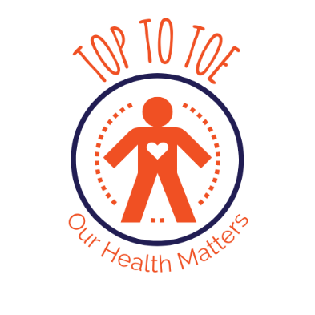
Top to Toe – Our Health Matters

If you are interested in Top to Toe please tell us a bit about yourself.

Name:

Date:

Are you a Member of KeyRing?
- Yes
- No

Where did you hear of Top to Toe?
- Social Worker/Care Manager
- Children, Adults and Health Department
- Health Service
- Other
- Online
- Leaflet
- Your doctor/district nurse
- Friend

How should we contact you about Top to Toe?

- Email (please give your email address)

- Phone (please give your phone number)

Is there anything else you would like to tell us?

There are rules that KeyRing has to follow about how we look after everyone’s personal data. Personal data is your name, contact information, and anything that means people can find out who you are and things about you that are private. We can only keep it for a good reason. We have to make sure we keep this information safe. If we don’t we will be breaking the law. If you would like to find out more about our approach to keeping your data safe please contact us Toptotoe@keyring.org.

